* **LAB 02: To learn physical Database Design.**

1. A book is identified by its ISBN number, and it has a title, a price, and a date of publication. It is published by a publisher, which has its own ID number and a name. Each book has exactly one publisher, but one publisher typically publishes multiple books over time.

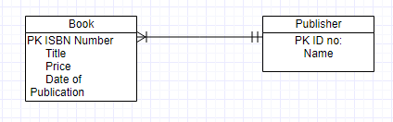

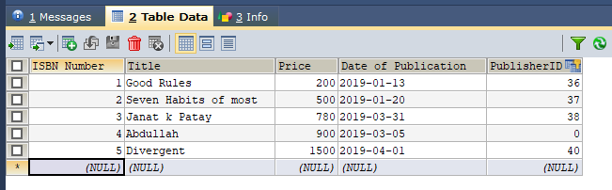

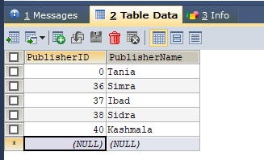

**Task: Make the tables of lab1 ERDs. Whose description is given below:**

* A piano manufacturer wants to keep track of all the pianos it makes individually. Each piano has an identifying serial number and a manufacturing completion date. Each instrument represents exactly one piano model, all of which have an identification number and a name. In addition, the company wants to maintain information about the designer of the model. Over time, the company often manufactures thousands of pianos of a certain model, and the model design is specified before any single piano exists.
* A piano manufacturer (see above) employs piano technicians who are responsible for inspecting the instruments before they are shipped to the customers. Each piano is inspected by at least two technicians (identified by their employee number). For each separate inspection, the company needs to record its date and a quality evaluation grade.
* The piano technicians (see above) have a hierarchy of reporting relationships: Some of them have supervisory responsibilities in addition to their inspection role and have multiple other technicians report to them. The supervisors themselves report to the chief technician of the company.

**Designer**

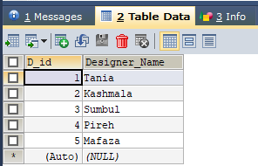

**Inspection**

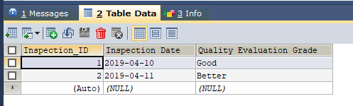

**Company**

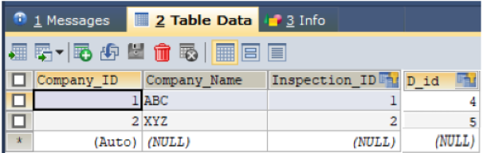

**Piano**

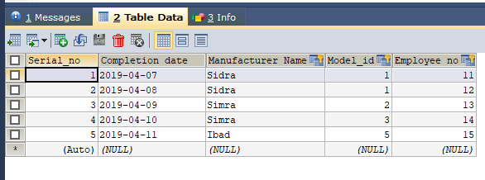

**Piano Manufacturer**

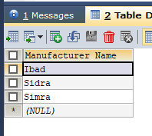

**Piano Model**

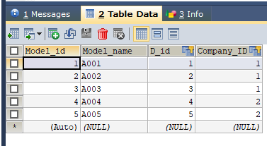

**Piano Technician**

